**WORD CLOUD & SENTIMENTAL ANALYSIS**

**Business Problem** = ﻿﻿﻿﻿﻿﻿﻿Extracting reviews of Mobile from Snapdeal and performing sentimental analysis.

* **Name of Product : -** XOLO ERA 2
* **Website : -** Snapdeal.com
* **Review URL : -** ﻿﻿<https://www.snapdeal.com/product/xolo-era-2-8gb-black/>

639365186960/reviews?page=dpproductdetail_text?ie=UTF8&showViewpoints

* **Review Extracted : -** 572

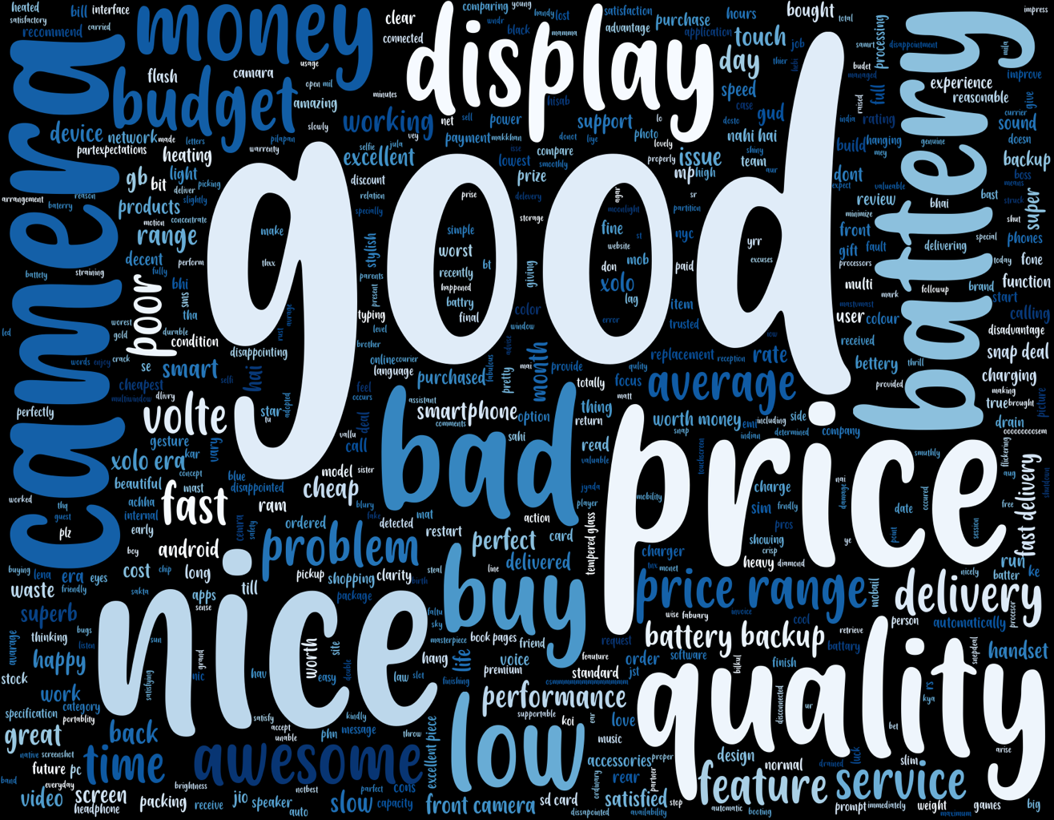**Word Cloud** =`

From the Above word cloud, we can conclude that the quality of mobile is Good and it is in budget mobile.

**Positive Sentimental Analysis =**

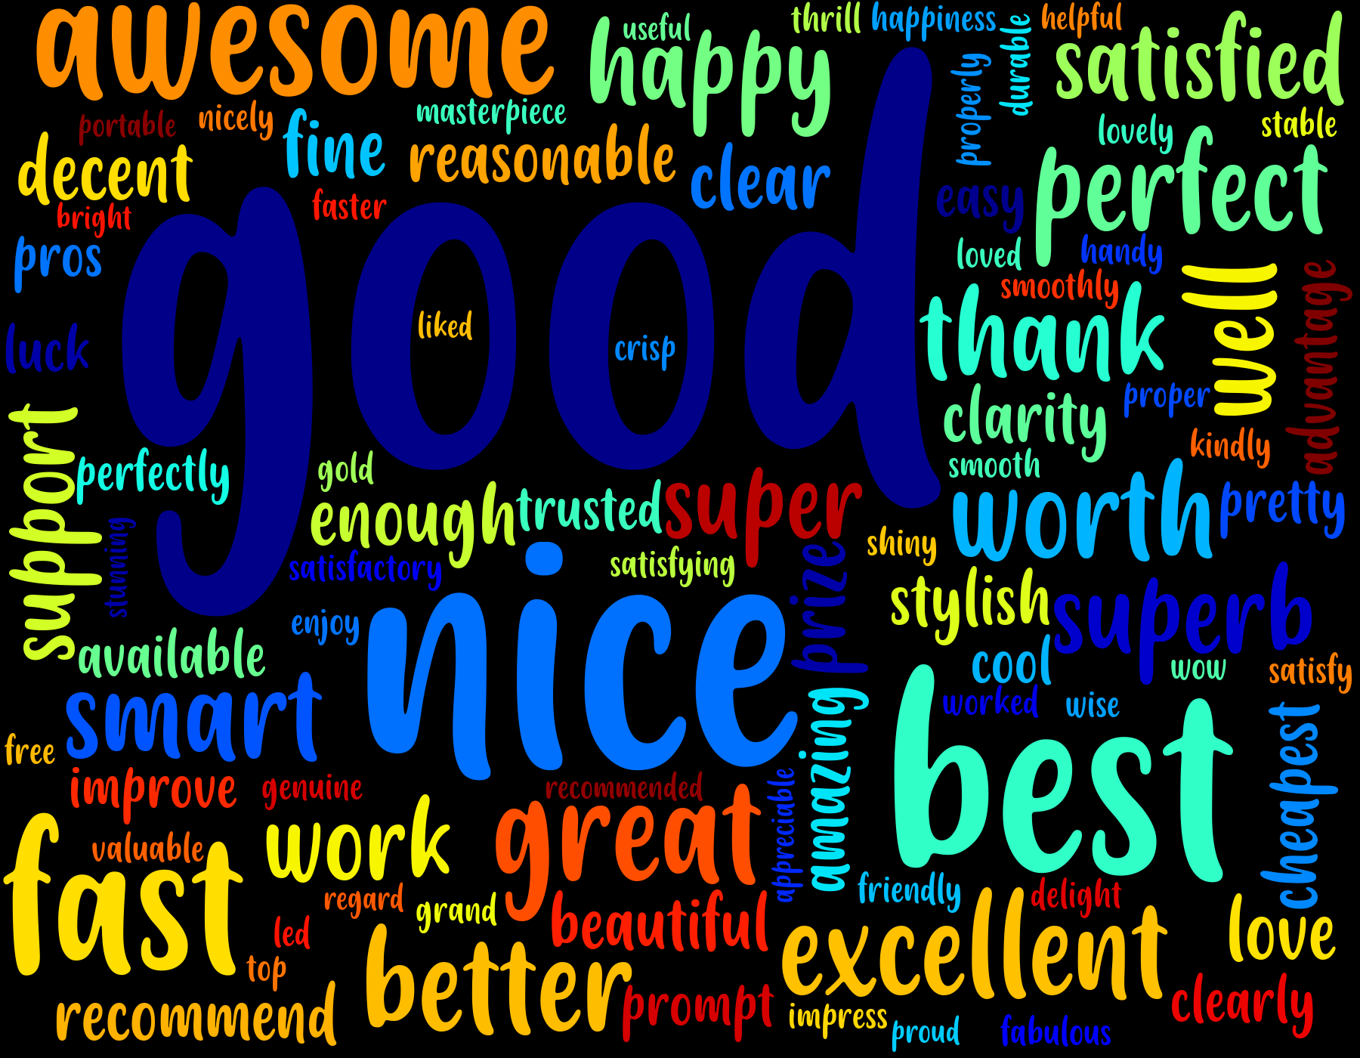

This all are positive responses of customer on Mobile.

**Negative Sentimental Analysis =**

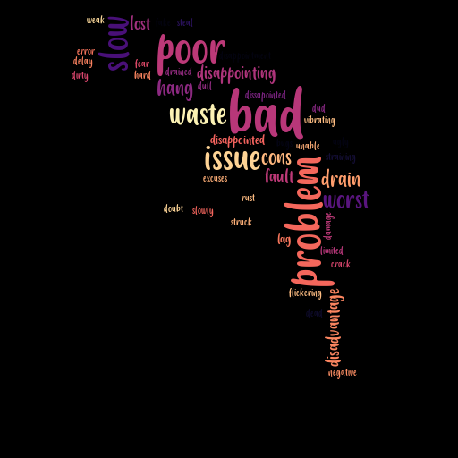

Drawbacks of mobiles which we can clearly observe in above negative sentimental Word Cloud .

**Python code file**: - [Snapdeal Word Cloud (Mobile).py](https://github.com/nilaydeshmukh0/Text-Mining-and-Sentiment-Analysis/blob/master/Snapdeal%20Product%20Analysis/Snapdeal%20Word%20Cloud%20(Mobile).py)